

Kindergarten News

Sight Words

and



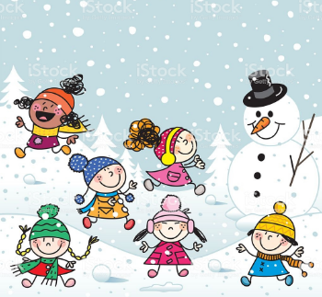
Upcoming events
November 19th – Report Cards go home
November 20th – Multi-age School Team Building (Wear your school team coloured t-shirt or a shirt of the same colour)
November 22nd (pm) – Parent-Teacher Conferences
November 23rd (am) – Parent-Teacher Conferences (No school for students)
December 13th – Christmas Dinner for students ($5.75 – sliced roast turkey, mashed potatoes, vegetables, cranberry sauce, savory stuffing, gravy, Christmas dessert)

Notes from the teacher:
I hope you were able to enjoy the snow and the long weekend.
The cold and snow is here! Students are expected to wear their snow pants to and from school. Keep encouraging your child to dress themselves. Independence is important for their success. Thank you.
Please continue to practice letter recognition & sounds, sight words and counting regularly.
Check out your FreshGrade accounts if you have not already done so.
If you have any questions or concerns please feel free to contact me at rolly.sidik@nbed.nb.ca, or call the school.



What we are learning this week:

Reading | Writing | Math | You and Your World
- Letters: F, B  - Sight Word: and  - Strategy: Lips the Fish – Get your mouth ready. Say the first sound.  - Review letters: s, a, t, i, p, n, c/k, e, h, r, m, d, g, o, u, l | - Practice proper letter formations for: f, b, u, l, o, p, n, t, i, s, a, c/k, e, h, r, m, d, g, o  - Practice reading, writing and spelling sight words: and, was, the, is, me, I, to, it  - Practice writing their names | - Say the number sequence 0-10.  - Represent and describe numbers  - Subitizing ( Recognize a familiar arrangements of objects at a glance)  - Relate a numeral to its quantity 0 to 5  - Identify, create and reproduce patterns | - Roles and responsibilities of family members.  - W.I.T.S. Strategy  - Habit 2: Begin with the end in mind. (I plan ahead and set goals. I do things that have meaning and make a difference. I am an important part of my classroom. I look for ways to be a good citizen.)

